Trent Giever

Debbie Wolf

CS 140

2/14/19

Ch 8

1. Create a Site Collection \*\*remember to use Administrator as site collection administrator--not your name

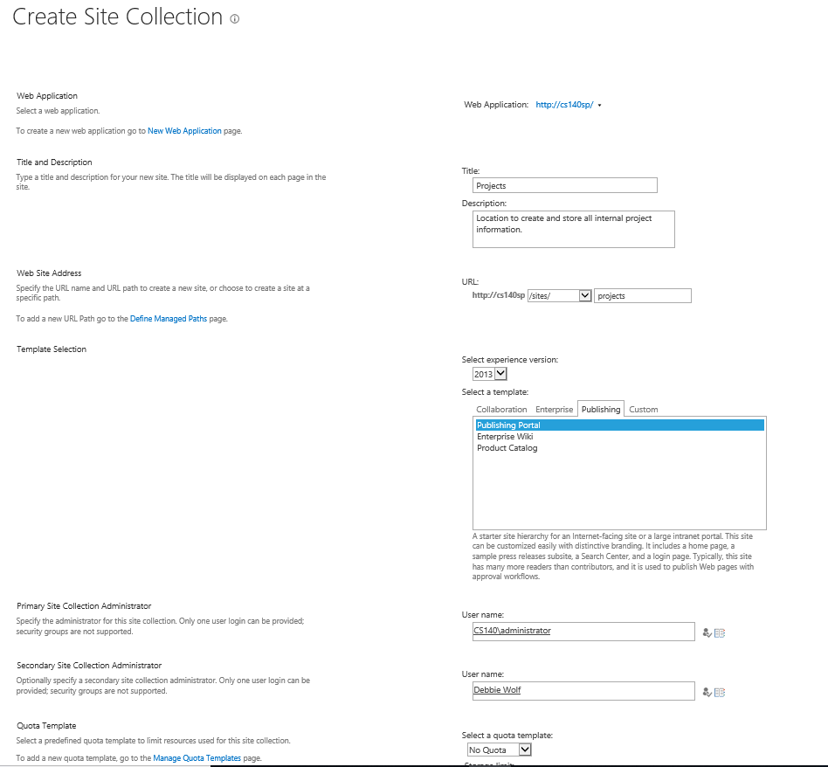

1. Create a Web(subsite)

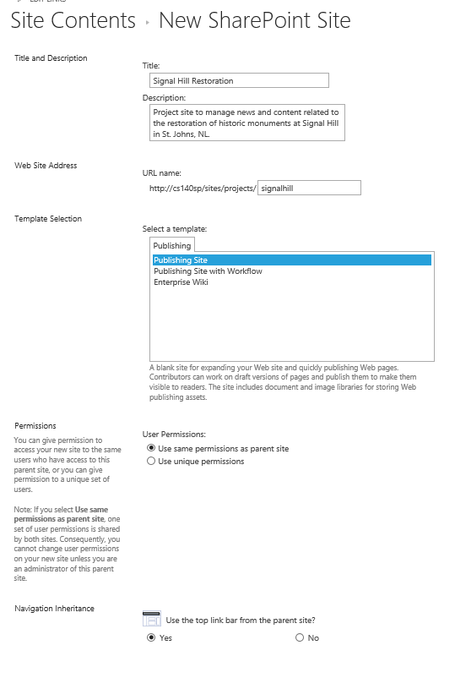

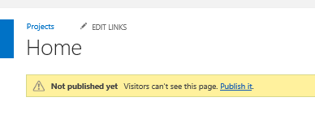

1. Changing the Available Site Templates for a Site

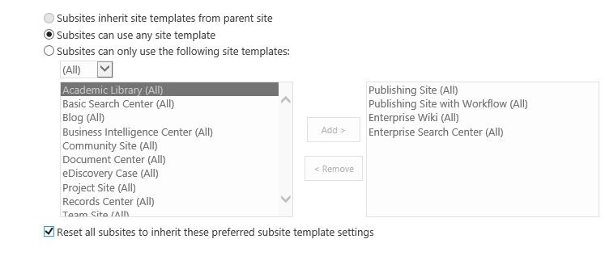

1. Changing the Navigation Options for a Site

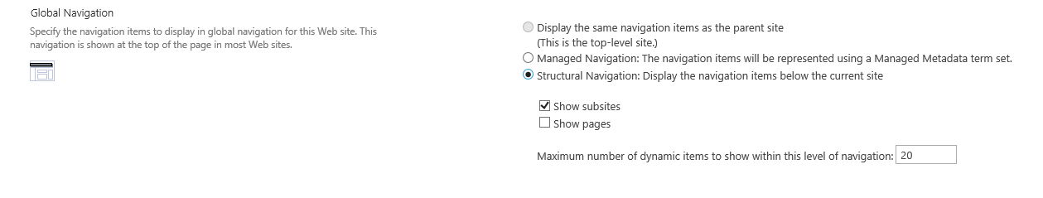

1. Enabling Tree view menu

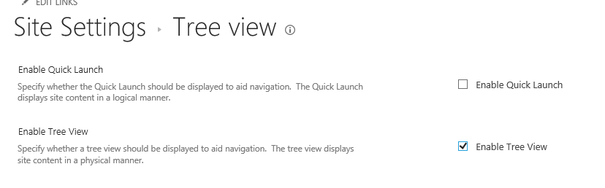

1. Adding a Custom Link to a Navigation

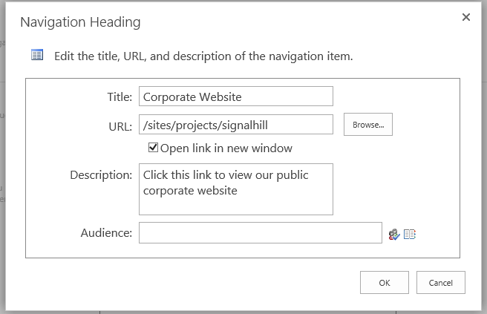

1. Changing the Order of Navigation Links

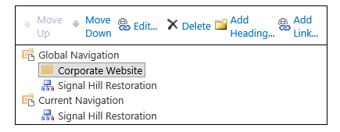

1. Adding a Feature
2. Creating and Moving a site from the Site Content and Structure Page

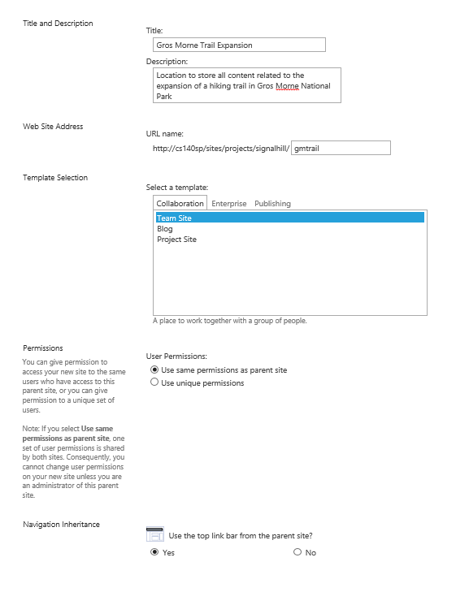

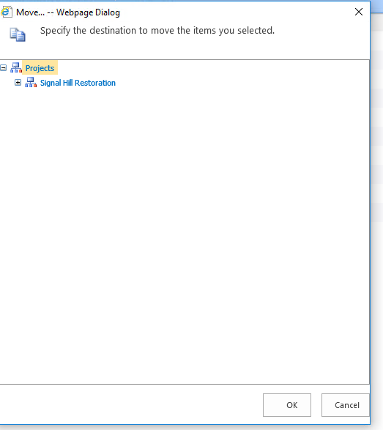

1. Save Site as a Template

